**EVENT BINDING DATA**

1. 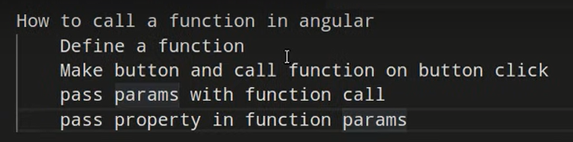Call Function

* Define a function:

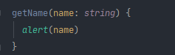

* Make button and call function on button click + pass param with function call



* Pass property in function params



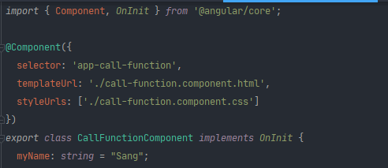

1. Event (https://angular.io/guide/user-input)

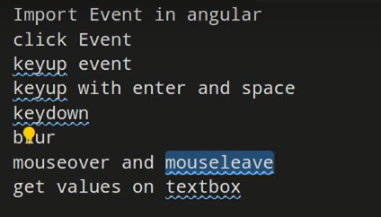

* Click Event:

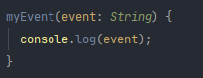

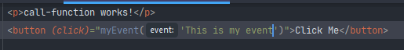

* KeyUp Event:
  + Cách 1: => inputValue: String = “sang”



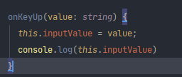

* + Cách 2:

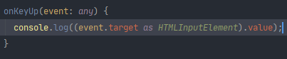

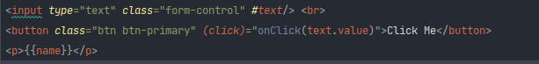

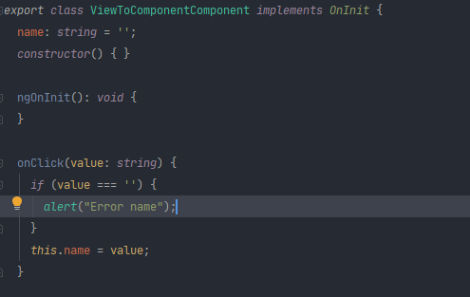

PROPERTY BINDING

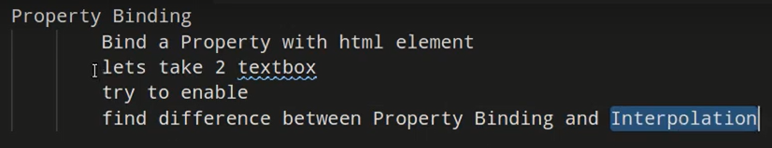

CONDITION STATEMENT

